Cryptomonas Ehrenberg 1831
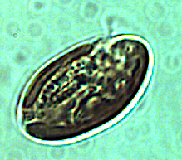
Phylum: Cryptista
Class: Cryptophyceae
Order: Cryptomonadales

Habitat: plankton pelagic/littoral
Distinctive features: heavily grazed by zooplankton, contains phycoerythrine (like cyanobacteria), its chloroplast fluorecses orange when observed under epifluorescent microscope. Always present in the water column of Lake Kinneret, with peak biomass in winter and another peak in summer. Distinctively larger size than Plagioselmis. Probably mixotrophic.
Organization: flagellated single cells
Color: dark brown
Cell shape: oval
Cell diameter (D): 6 – 17 μm, median: 9.2 μm (N=2400).
Cell length (L): 10 – 30 μm, median: 14 μm (N=424).
Cell biovolume: 400 – 2000 μm³, median: 700 μm³. Larger cell size in winter, smaller in summer (see Figs. 2, 4).
Biovolume equation: V=0.7076D^{3.0772} (regression eqn. based on 424 measurements of both D and L with V computed for a prolate sphaeroid).

Morphological features: Relatively large free-swimming cells, dark brown in color, shaped as an elongated monad with two equal or subequal length flagella extending out of a gullet (longitudinal groove on the cell surface) in the upper part of the cell. The bottom end is rounded. With 1 or 2 chloroplasts per cell located at the cell periphery, phycoerythrin as the principal accessory pigment (giving the deep brown color), and a single large and central pyrenoid. Cryptomonas is differentiated from Plagioaselmis in being the larger cryptophyte found in Lake Kinneret. Three species of Cryptomonas occur in the lake, including C. ovata, C. marssonii and C. curvata (Plates 1-3). Dues to the similar size and limited diagnostic characters, for the routine monitoring the 3 species have all been counted under a single code for the genus Cryptomonas, and the data presented in figures 1-4 are for the genus.

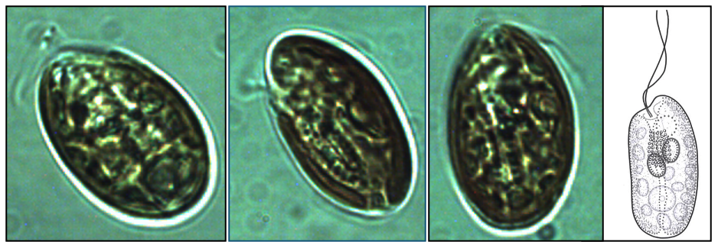
Plate 1. Cryptomonas ovata from L. Kinneret showing typical ovoid shape, dark brown color and two equal-length flagella emerging out of a gullet system that reaches the center of the cell or beyond. In lateral view the cells are elliptical, elongated, ovoid, often slightly curved. The furrow-gullet system is straight or slightly curved. Photographs by Alla Alster. Drawing from B-Beres 2024.
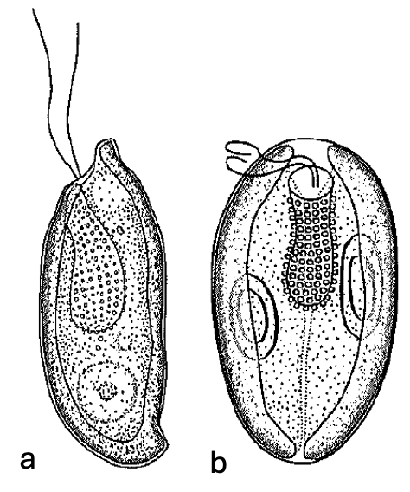
Plate 2. Cryptomonas curvata Ehrenberg from L. Kinneret. This species appears in two morphs: (a) S-shaped in lateral view, or “campilomorph”; (b) more symmetrical oval-to ellipsoid form, or “cryptomorph”. In both, the flagella are subequal. Drawing from B-Beres 2024.

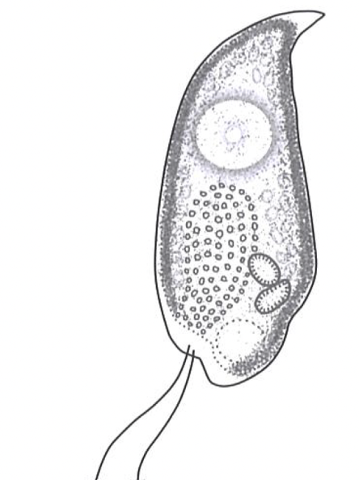
Plate 3. Cryptomonas marssonii Skuja showing typical tapering of cell towards the posterior end and being lightly curved. With 2 subequal flagella. The furrow-gullet system is oblique, it extends to about half of the cell. With 2 olive-green or olive-brown chloroplasts. Drawing from B-Beres 2024.

Ecology: Cryptopmonas spp. are always present in the water column (Fig. 1), with higher abundances in winter (Dec to Feb) but also in summer (Jul - Sep) and lowest in April-May, at the time of the Peridinium bloom (Fig. 2). It is possible that the two seasonal abundance peaks are due to two different Cryptopmonas species. Abundance is usually < 250 cells/mL (Fig. 2). A noteworthy exception occurred during the cold winter of 1992, when the Peridinium bloom developed later than usual and Cryptomonas abundance in February exceeded 1000/mL (Fig. 1). Overall, when Peridinium gatunense is abundant in the water, Cryptomonas spp. abundance is low, and visa-versa (Fig. 3). Cell size of Cryptomonas varies seasonally, with larger cell volume in winter (Fig. 4a).

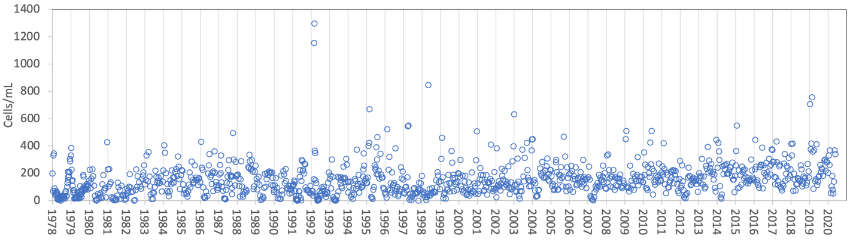
Figure 1. Time series of Cryptomonas spp. abundance (cells mL⁻¹), Lake Kinneret, 1978-2020.
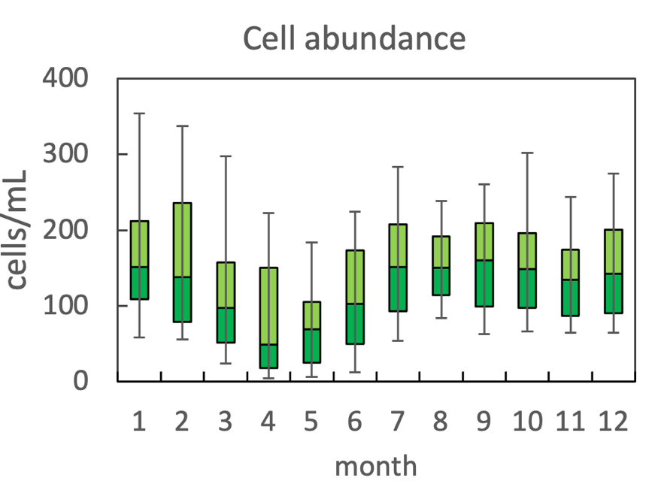
Figure 2. The annual pattern of water column cell abundance of Cryptomonas spp. in Lake Kinneret, based on data for 1978-2020. Statistics shown are: median – middle line; 25th to 75th percentiles – box content; 90th and 10th percentiles - top and bottom bars, respectively.
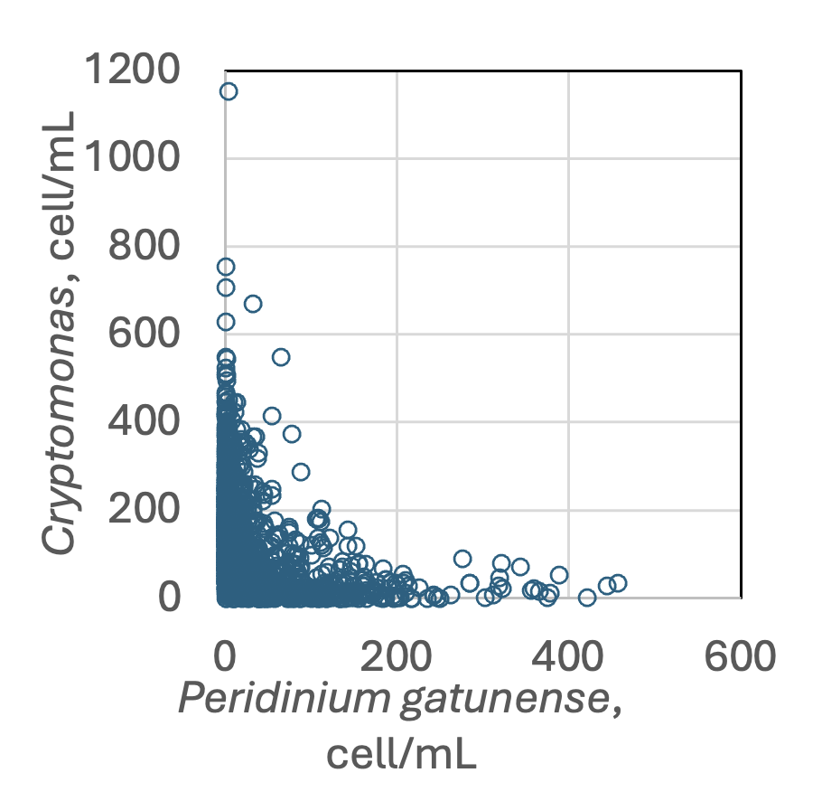
Figure 3. Cryptomonas spp. abundance vs. that of Peridinium gatunense, based on data for 1970-2020. Higest abundance of Cryptomonas spp occurrs when Peridinium gatunense abundance is lowest, and visa-versa.

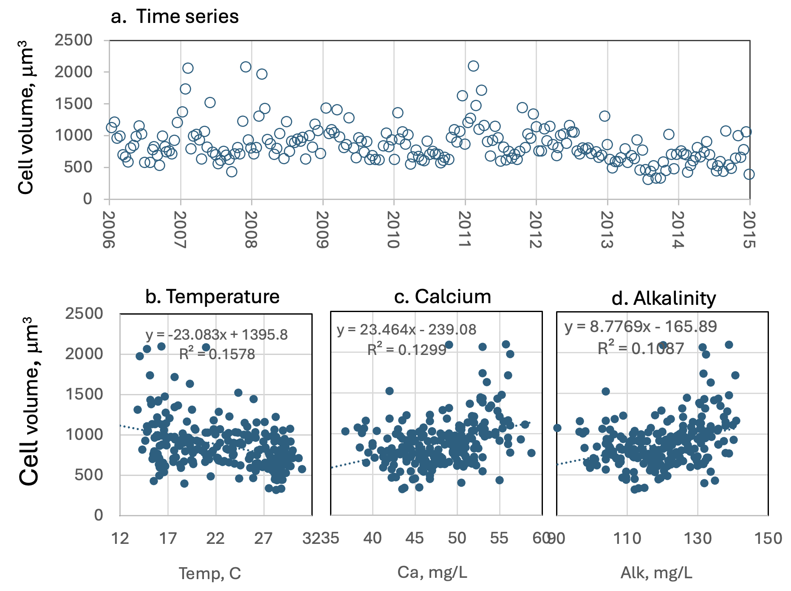
Figure 4. Crytomonas cell size (as volume, μm³): (a) time series, showing tendency for larger cells at the beginning of each calendar year. (b-d) Regressions against temperature, calcium and alkalinity, respectively, showing weak but significant correlation of cell size with each of those variables.
Environmental conditions:
Kinneret Crytomonas is resistant to higher chloride concentrations and is present at all ambient water temperatures (Fig. 5). High abundances of Cryptomonas spp. are associated with: mixing depth (Zmix) > 35 m typical of the winter time when the water column is fully mixed; euphotic zone depth range of 5-12 m (not shown); higher alkalinities; lower organic N (Fig. 5).
Cell size tends to deline with water temperature and increase with Alkalinity and Ca concentration (Fig. 4 b,c,d).

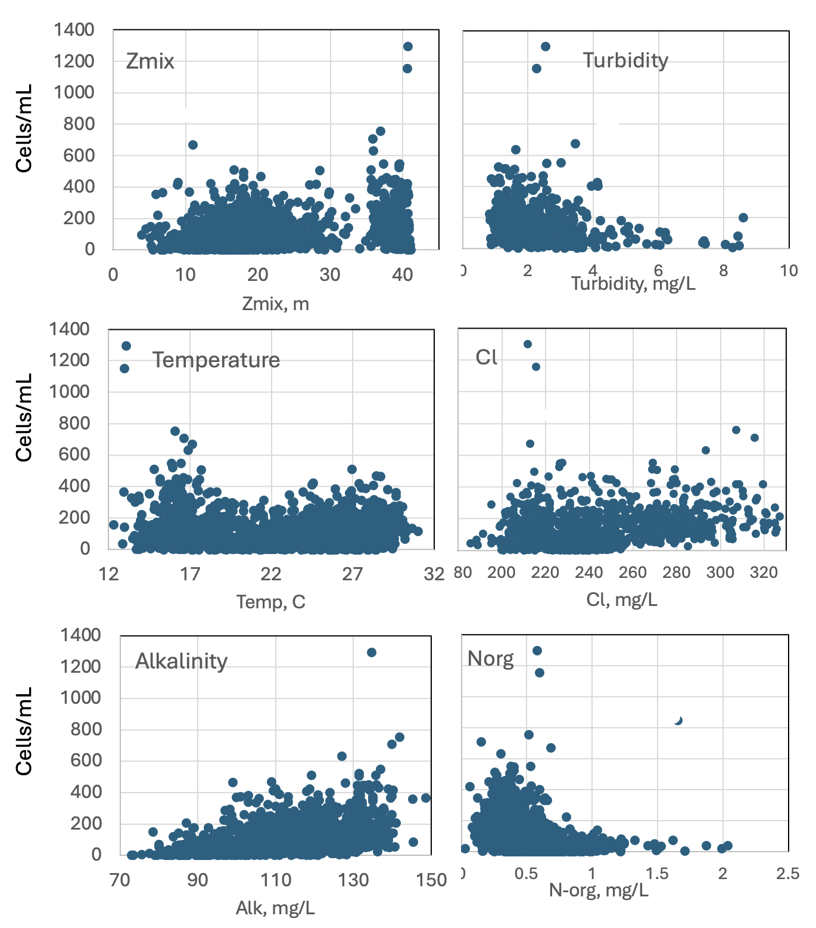
Figure 5. Crytomonas spp. abundance (cells mL⁻¹) vs. environmental parameters recorded at the site and time of sampling.

Cite this record as:
Tamar Zohary, Alla Alster. 25 April 2026. Electronic publication. Israel Oceanographic & Limnological Research. [Date when last accessed].
Further reading:
Javornicky P 2003. Cryptomonas ovata Ehrenberg (Cryptophyceae) and some related species. Algological Studies/Archiv für Hydrobiologie, Supplement 110: 43-65.
Novarino G 2011. Cryptophyta (Cryptomonads). In: The freshwater algal flora of the British Isles. An identification guide to freshwater and terrestrial algae. Second edition. (John, D.M., Whitton, B.A. & Brook, A.J. Eds), pp. 240-249. Cambridge: Cambridge University Press.
B-Beres V. 2024. Az egybarazdas moszatok [cryptophyceae] kishatarozoja. Hun-REN OK VOI, Funkcionalis Algologgiai Kutatocsoport.

Plagioselmis nannoplanctica (Skuja) Novarino et al. 1994
Previous name used: Rhodomonas minuta var. nannoplanctica Skuja 1948
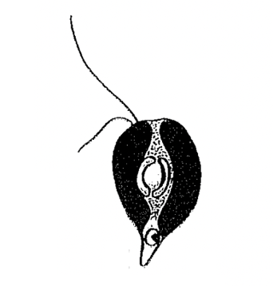
Phylum: Cryptista
Class: Cryptophyceae
Order: Cryptomonadales

Habitat: plankton, pelagic/littoral
Distinctive featureses: heavily grazed by zooplankton, contains phycoerythrine (like cyanobacteria) – fluorecses orange when stained with DAPI. Always present in the water column. Distinctively smaller size than Cryptomonas. Probably mixotrophic.
Organization: flagellated single cells
Color: reddish to dark brown
Cell shape: drop-like
Cell diameter (D): 3 – 6 μm, median: 4.5 μm (N=477).
Cell length (L): 6 – 10 μm, median: 7.8 μm (N=390).
Cell biovolume: 40 – 150 μm³, median: 82 μm³.
Biovolume equation: V=1.841D^{2.5264} (regression eqn. between D and V based on 390 measurements of both D and L with V computed for a Half sphere + cone; R²=0.93).
Morphological features: A small drop-shaped monad with two slightly unequal flagella (Plate 1), this is the smaller cryptophyte of Lake Kinneret. A single red (contains phycoerythrin) chloroplast is dorsal with ventral margins. A central large pyrenoid surrounded by a thick startch sheath of 2 hemispherical halves. The nucleus is posterior. Its chloroplast fluoresces orange (auatofluorescence) when observed under an epifluorescent microscope.

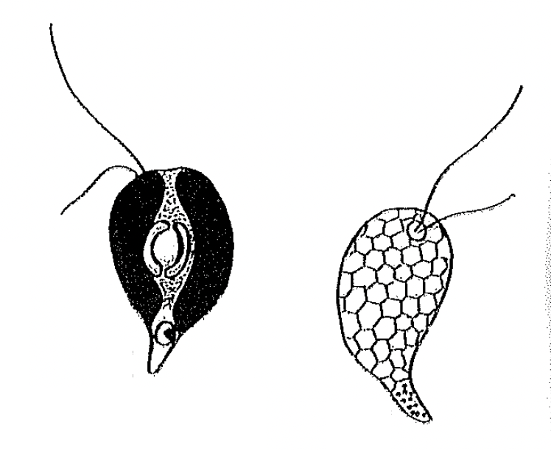
Plate 1. Plagioselmis nannoplanctonica (previously named Rhodomonas minuta va. nannooplanctonica). Showing typical drop shape, and unequal flagella emerging from a groove at the top, rounded part of the cell. Left drawing shows also the periferal chloroplast (black), central pyrenoid surrounded by a thick starch sheath of two hemispheral halves. Right drawing shows details of cell surface seen by scanning electron microscopy. Drawing taken from Novarino (2002).
Ecology: Plagioselmis nannoplanctonica is present in the Kinneret water column, in the pelagial and littoral, at all times of year, and has been present continuously since 1970 (Fig. 1). It has a distinct annual cycle of peak abundance during winter holomixis (Dec. to Mar.), lowest in summer (Jun. to Oct.; Fig. 2). Indifferent to increasing salinity (or Cl⁻ conc.; Fig. 3). Like Cryptomnonas, it is present in both the pelagic and littoral zones and is highly grazed by zooplankton.
Environmental conditions: Present at the full range observed in Lake Kinneret of the following environmental variables: Zeu (euphotic zone depth), Secchi depth, pH, NH₄, DO, SO₄, TSS, Turbidity. Abundance increases with increasing alkalinity and nitrate, and with declining water temperature, DON, Organic N, total dissolved P (Fig. 3).
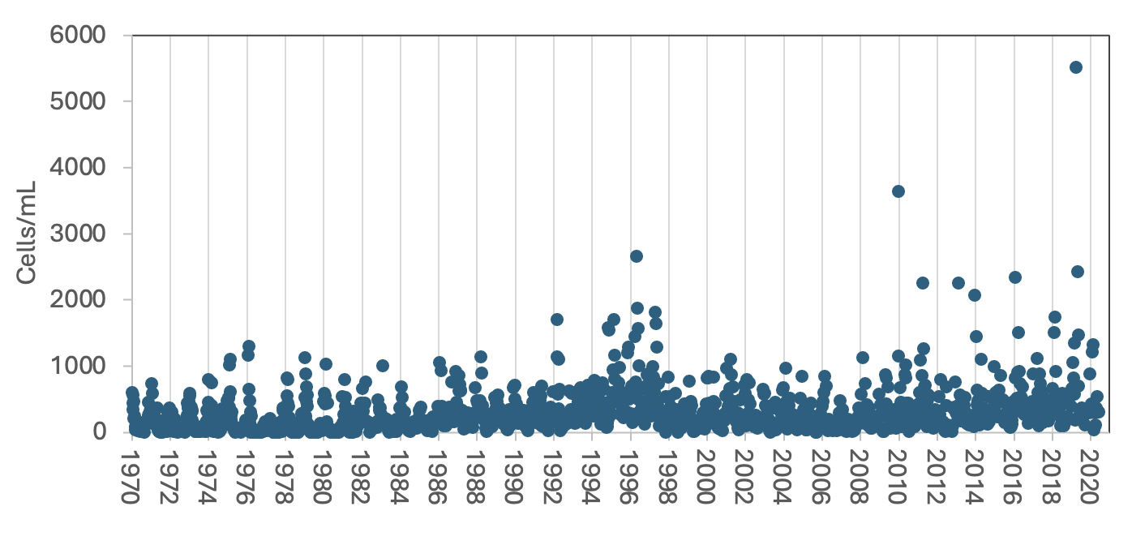
Figure 1. Figure 1. Time series of Plagioselmis nannoplanctonica abundance (cells mL⁻¹), Lake Kinneret, 1970-2020.

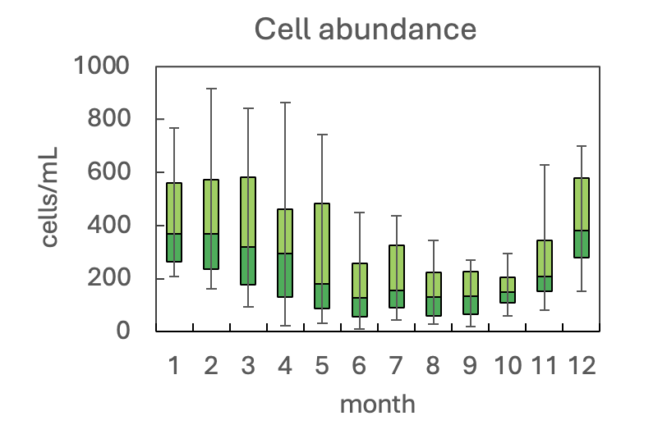
Figure 2. The annual pattern of water column cell abundance of Plagioselmis nannoplanctonica in Lake Kinneret, based on data for 1970-2020. Statistics shown are: median – middle line; 25th to 75th percentiles – box content; 90th and 10th percentiles - top and bottom bars, respectively.
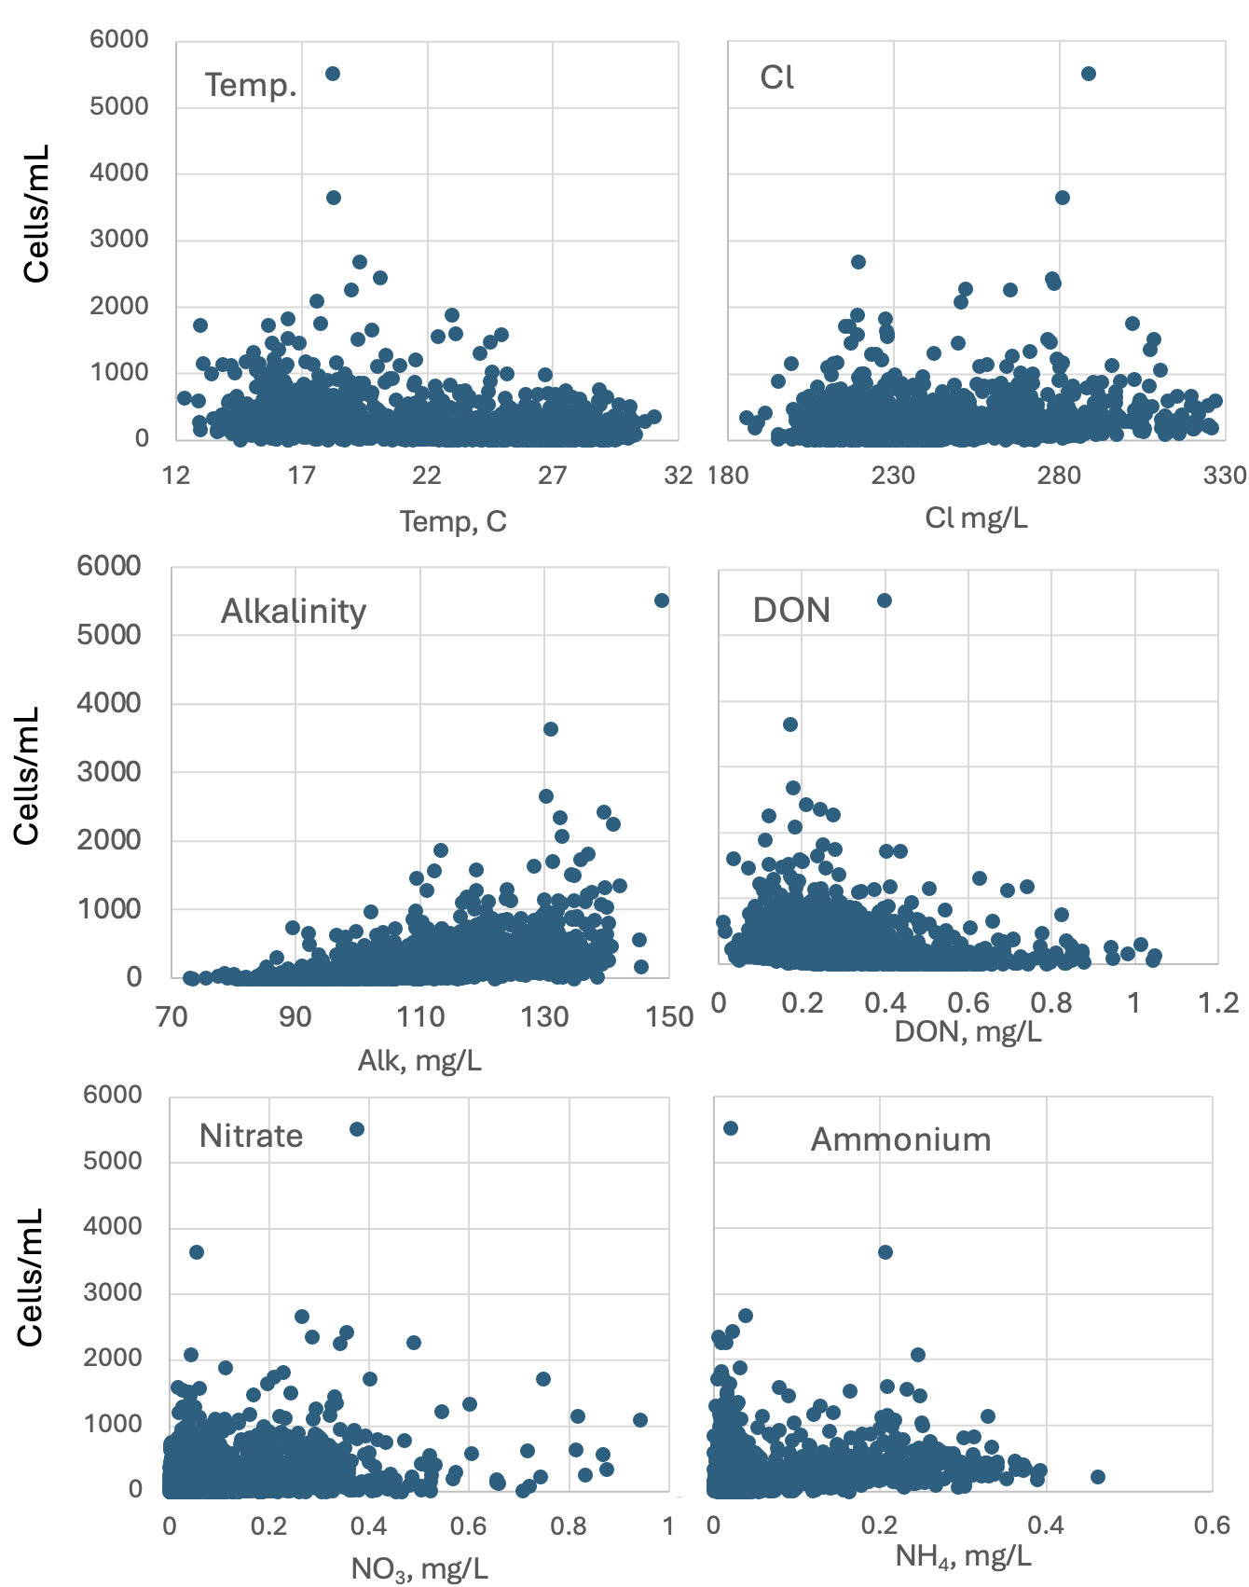
Figure 3. Plagioselmis nannoplanctonica abundance (cells mL⁻¹) vs. environmental parameters recorded at the site and time of sampling.
Cite this record as:
Tamar Zohary, Alla Alster. 26 April 2026. Electronic publication. Israel Oceanographic & Limnological Research. [Date when last accessed].
Further reading:
Lund JWG 1962. A rarely recorded but very common British alga, Rhodomonas minuta Skuja. British Phycological Bulletin, 2: 133-139.
Novarino G 2002. Cryptophyta (Cryptomonads). In: The freshwater algal flora of the British Isles. An identification guide to freshwater and terrestrial algae. Eds: John DM, Whitton BA, Brook AJ. pp. 240-249. Cambridge: Cambridge University Press.
B-Beres V 2024. Az egybarazdas moszatok [cryptophyceae] kishatarozoja. Hun-REN OK VOI, Funkcionalis Algologgiai Kutatocsoport.

Tetraselmis cordiformis (Carter) Stein 1878
Previous name used: Carteria cordiformis Diesing 1866
Phylum: Chlorophyta
Class: Chlorodendrophyceae
Order: Chlorodendrales

Habitat: plankton
Distinctive features: relatively large cell size with 4 flagella.
Organization: flagellated single cells
Color: green
Cell shape: sphaeroid
Cell diameter (D): 10.2–15.9 μm, median: 13.1 μm (N=526).
Cell length (L): 13.4–18.7 μm, median: 15.9 μm (N=526)
Cell biovolume: 730-2400 μm³, median: 1400 μm³.
Biovolume equation: prolate spheroid V, μm³ = 4/3 p L/2 (D/2)² (or: regression eqn. based on >500 measurements of both D and L with V computed for a prolate sphaeroid:
V= 1.9507*D^{2.5651}

Morphological features: One of the larger flagellated species of Lake Kinneret (after the dinoflagellates), and the only one with four flagella (Plate1). It is heart-shaped (=cordiform, as it’s name) or cherry-shaped, ellipsoidal or almost sphaerical, never twisted, with four equal-length flagella emerging out of a pit or depression in the upper side of the cell (Plate 1). It has a red eyespot or stigma, and a single cup-shaped chloroplast usually with a basal pyrenoid. Two contractile vacuoles are present near the base of the flagella.
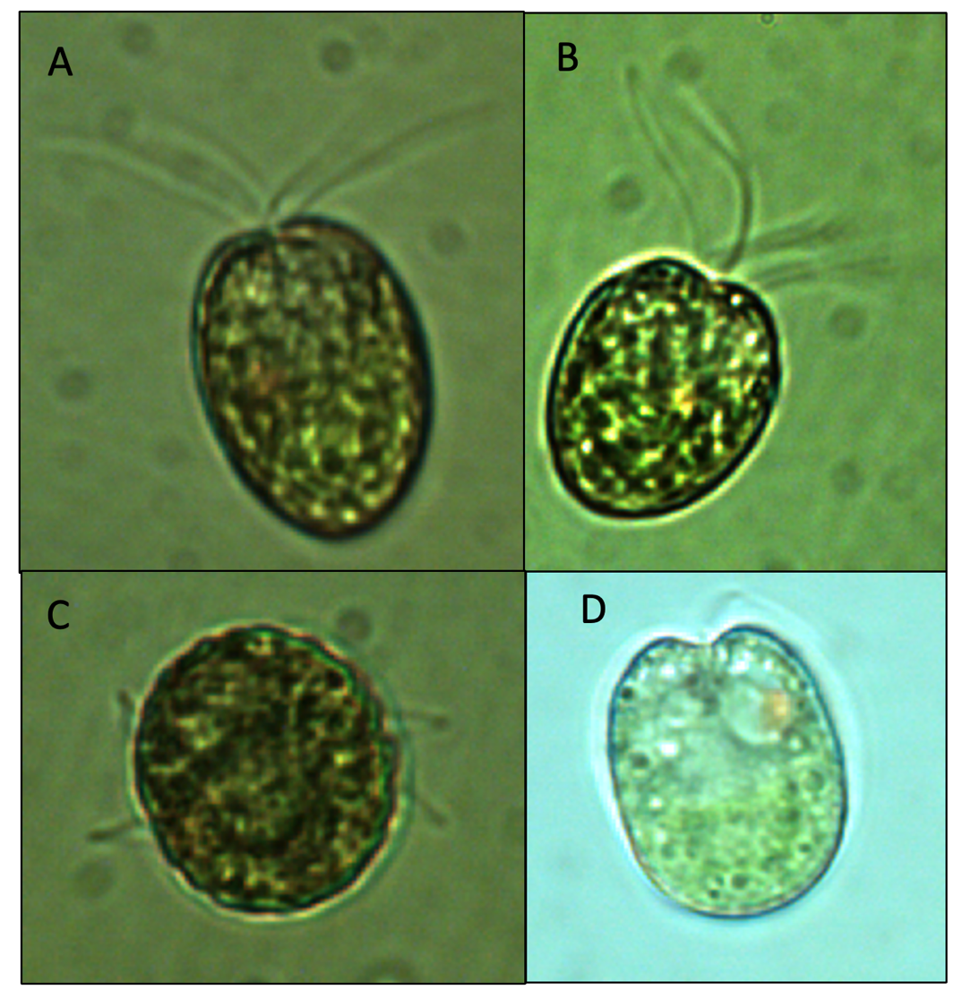
Plate 1. Tetraselmis cordiformis (live material) seen with its heart or cherry-shape, 4 flagella and reddish-brown eyespot. A, B, D – front view. C - Specimen viewed looking at its “bottom” side with only the ends of the four flagella visible. Photos: Alla alster.
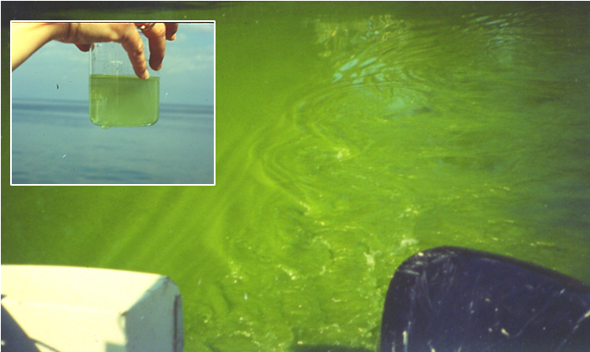
Plate 2. A massive bloom of Tetraselmis cordiformis on 19 February 1996: the entire lake water turned grass green, as seen in the green trail of water behind our sampling boat and as seen more closely in a hand-held beaker of lake water (inset). Photos: Tamar Zohary.
Ecology: Tetraselmis cordiformis usually occurs in the Kinnret plankton in small numbers of < 50 cells/mL (Fig. 1) and biomas not more than 4 g m⁻² (not shown). It is more abundant between February and April and again from August till November but absent in July and rare in December and January (Fig. 2). A technician-effect is noted in our data: a technician was replaced on 1 Jan 2013. It is evident in Fig. 1 that the newer technician counted this species more frequqently than the previous one.
On a single unusual occassion in February 1996 Tetraselmis cordiformis formed an intense bloom that colored the entire lake with a strong grass-green color. This intense bloom disappeared within a few days and was missed by our weekly sampling, but photographic records remain (Plate 2). On another occassion, a massive bloom of this flagellated alga took place in a series of experimental tanks behind the Kinneret Limnological Institute. Again the bloom was short lived and disappeared within days.
A distinct annual cycle of cell size is evident from our data: cells are smaller size in summer, larger in winter (Figs. 2, 3A). Cell size correlates well with water temperature (R²=0.48, Fig. 3B).
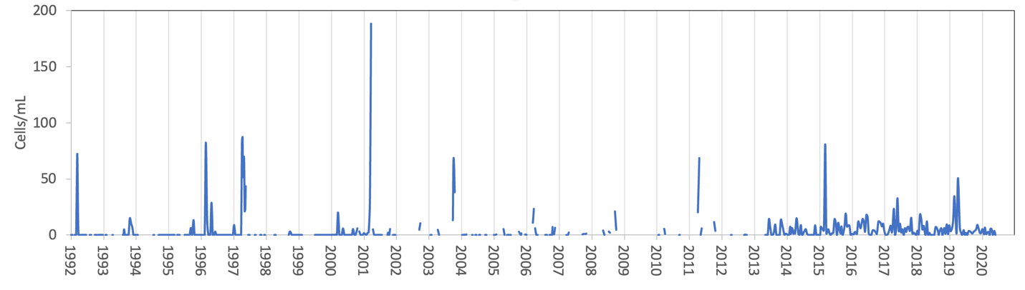
Figure 1. Time series of Tetraselmis cordiformis abundance (cells mL⁻¹), Lake Kinneret, 1992-2020. The greater frequency of observations of the species from 2013 onwards is likely due to change of the technician doing the microscope counts on 1 Jan 2013.
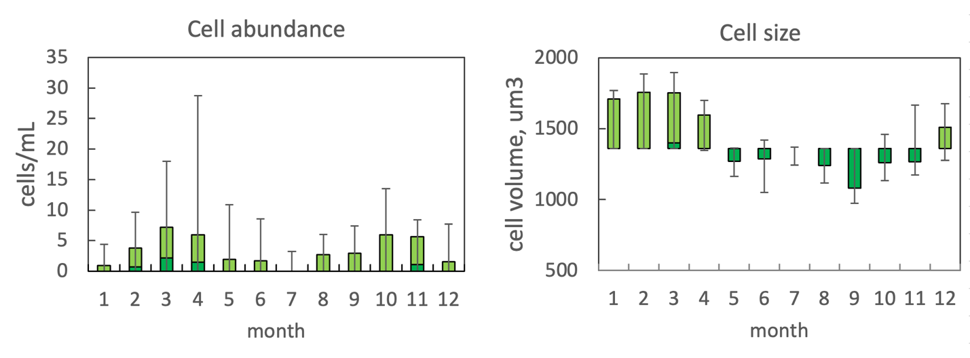
Figure 2. The annual pattern of water column cell abundance (left) and volume per cell (right) P. elpatiewskyi, based on data for 1992-2020. Statistics shown are: median – middle line; 25th to 75th percentiles – box content; 90th and 10th percentiles - top and bottom bars, respectively.

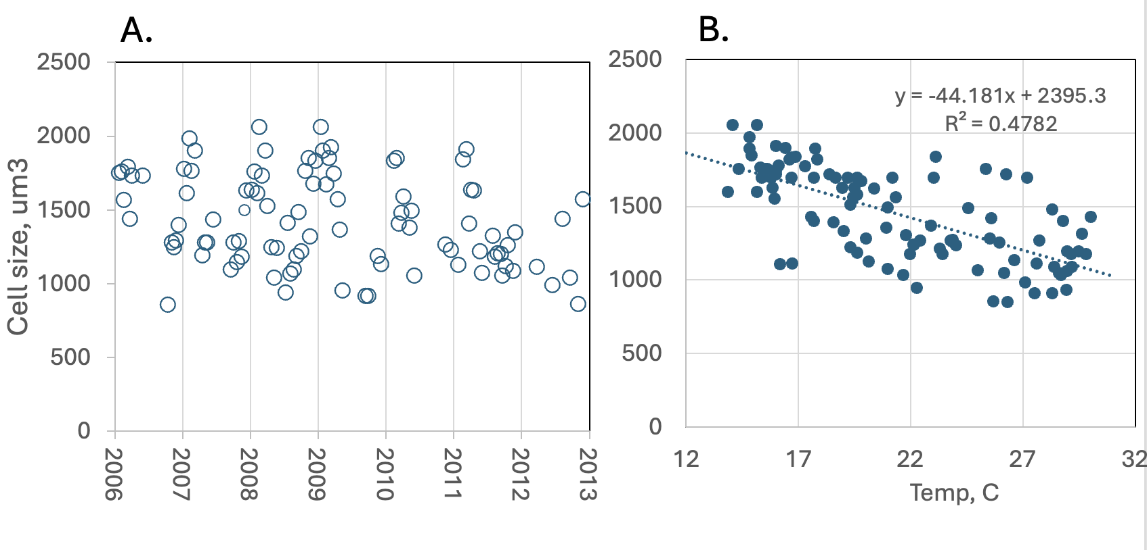
Figure 3. A. Time series of measured cell size, 2006-2012, showing largest size around January-February each year (grid lines indicate 1 January of each year). B. Regression of cell size against water temperature.
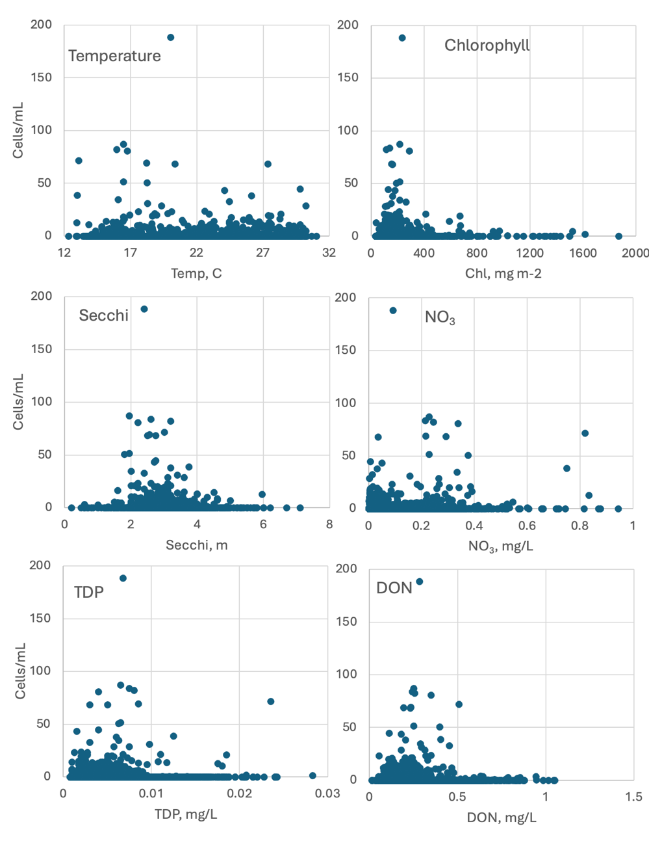
Figure 4. Tetraselmis cordiformis abundance (cells mL⁻¹) vs. selected environmental parameters recorded at the site and time of sampling.

Environmental conditions: T. cordiformis occurred at the full range of water temperatures occurring in the lake, at conductivities > 1000 μS cm⁻¹ and Chloride > 210 mgL⁻¹, when Secchi transparency was 2-4 m, euphotic zone depth > 5 m, mostly at pH between 8–9, Chlorophyll < 400 mg m⁻², at alkalinities > 100 mg L⁻¹, when NH₄ was low but NO₃, Norg and DON were moderate (Fig. 4).
Cite this record as: Tamar Zohary, Alla Alster. [Date when Item was last updated]. Electronic publication. Israel Oceanographic & Limnological Research. [Date when last accessed].

Chrysochromulina parva Lackey 1939
Previous name used: Erkenia subaequiciliata, Skuya 1948
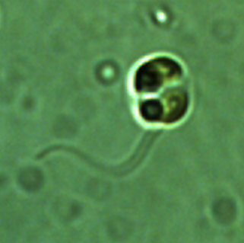

Phylum: Haptophyta
Class: Coccolithophyceae
Order: Prymnesiales

Habitat: plankton, pelagic/littoral
Distinctive features: A tiny flagellated species that is seasonally extremely abundant (thousands of cells/mL), probably mixotroph, heavily grazed by zooplankton.
Organization: flagellated single cells
Color: yellow to golden-brown
Cell shape: spheroid
Cell diameter (D): 2.9 – 5.2 μm, median: 3.9 μm (N=100).
Cell biovolume: 13 – 76 μm³, median: 34 μm³.
Biovolume equation: Sphere V, μm³ = 4/3 π *(D/2)³.

Morphological features:
This species comprises the smallest (3 - 5 μm diameter), but very common flagellates of Lake Kinneret (Plate. 1). Cells have a bilateral symmetry, spheroid shape except when dividing (Plate 2A), with 2 flagella of equal or near-equal length, 1 haptonema (Plate 2B), 2 chloroplasts, 2 contractile vacuoles, and a stigma (Plates 1, 2). The flagella are much longer than the cell. During swimming, one flagellum is directed forward, whereas the other trails behind. The haptonema that may be mistaken for a third flagellum, is a thread-like organelle used for attachment and catching prey. It is thinner and more delicate than the flagella and rarely seen under a light microscope, because it often contracts and hides against the cell wall. During cell division there is a stage when the two daughter cells are still contained within the same cell wall thus the cell seems particularly wide and with 4 flagella (Plate 2A).
Skyua, who first described Erkenia subaequiciliata in 1948, didn’t see its haptonema and placed it with the Chrysophyta, although in all other attributes it resembled the haptophyte Chrysochromulina parva Lackey 1939. With more advanced microscopy it was shown in the 1960s that the two species are identical, and the earlier name, Chrysochromulina parva, took over.
Plate 1. Chrysochromulina parva from Lake Kinneret. Note the small, spherical cell shape and the shape of the chloroplasts. A flagellum (only 1 of 2) is seen in the uppermost specimen.
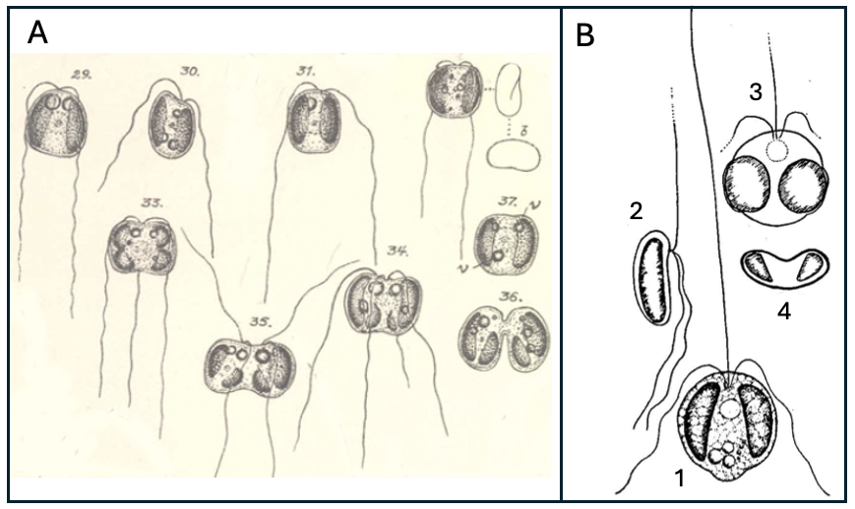
Plate 2. Hand drawing of Erkenia subaequiciliata Skuja= Chrysochromulina parva Lackey: A. by Skuja 1957, showing the life-cycle of this bi-flagellated species, including its division into two daughter cells (33-36). B. by Lackey 1939, showing the haptonema (pointed upwards in 1,2,3) as well as other details. 1 General structure. 2 lateral view. 3 Cell with round chromatophores, 4. Cross-section showing middle depression.
Ecology: Chrysochromulina parva is the smallest flagellated species occurring in Lake Kinneret. At times it is incredibly abundant, reaching concentrations of > 1000 cells mL⁻¹; an all-time maximum of 11,900 cells mL⁻¹ was recorded in April 2019 (Fig. 1). Despite their high abundance, their minute size makes their contiribution to total phytoplankton biomass usually negligible, on average only 0.4%. The max biomass contribution ever recorded was 7.9 g m⁻² and 13% of the total biomass. Chrysochromulina parva is abundant in winter – spring, it is rare or completely absent from the water column in the summer and re-appears in the fall (Fig. 2).
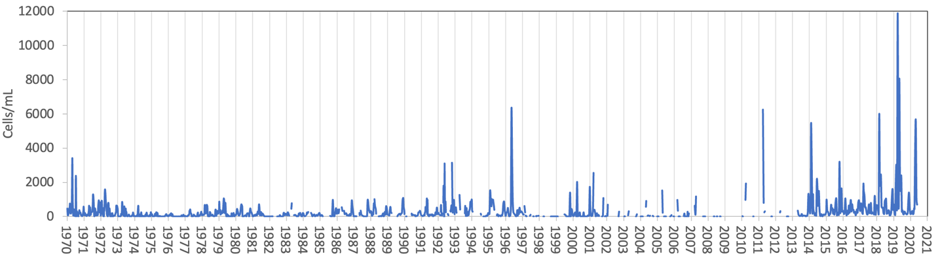
Figure 1. Time series of Chrysochromulina parva cell abundance in Lake Kinneret, 1970-2020.
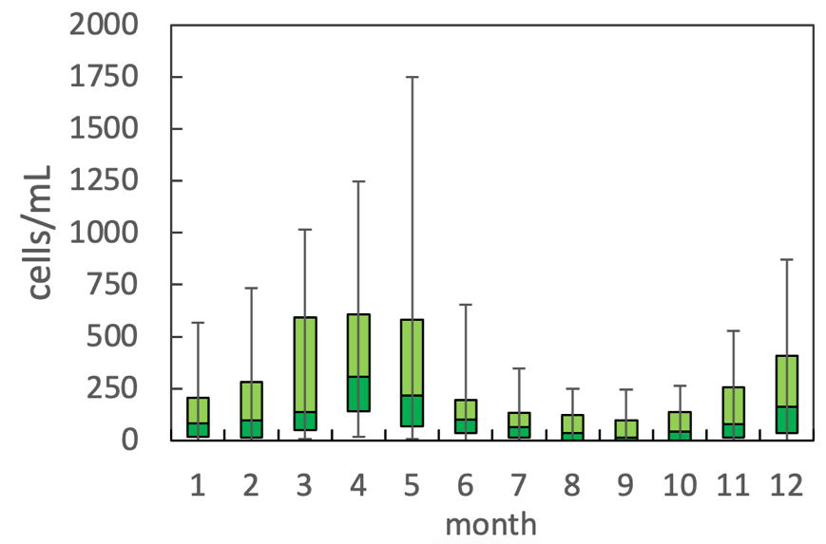
Figure 2. The annual pattern of water column cell abundance of Chrysochromulina parva, based on data for 1978-2020. Statistics shown are: median – middle line; 25th to 75th percentiles – box content; 90th and 10th percentiles - top and bottom bars, respectively.

Environmental conditions: occurs at the full range of temperatures, water levels, conductivities, chloride, alkalinity, Ca and nitrate concentrations recorded in Lake Kinneret. Higher abundances were restricted to a relatively narrow range of long wave radiation, between 325-375 Watt m⁻², to overall low chlorophyll concentration (i.e. not during major blooms of other species), at DON < 0.4 mg L⁻¹, NH₄ < 0.1 mg L⁻¹, organic N around 0.5 mg L⁻¹, pH in the range of 8-9 and Secchi depth between 1-4 m (Fig. 3).
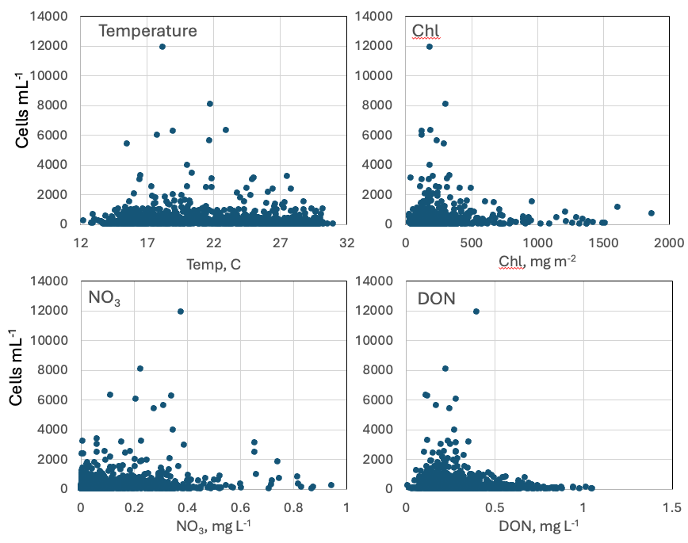
Figure 3. Chrysochromulina parva abundance (cells mL⁻¹) vs. selected environmental parameters recorded at the site and time of sampling, showing indifference to temperatue and nitrate but tendency for higher cell concentrations at lower chlorophyll and DON concentrations.
Cite this record as:
Tamar Zohary, Alla Alster. [Date when Item was last updated]. Electronic publication. Israel Oceanographic & Limnological Research. [Date when last accessed].

